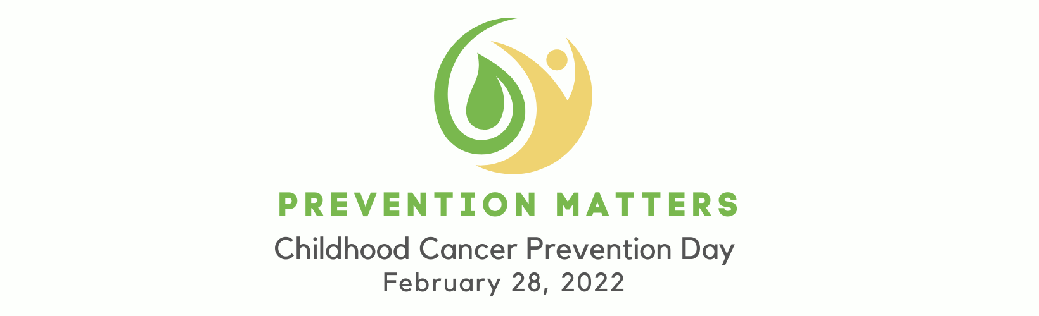

2022 Social Media Toolkit

Join us for the first Childhood Cancer Prevention Day! Prevention Matters – and the time is NOW to combine our voices in advocacy to raise awareness and educate the community about the importance of true prevention. Childhood cancer incidence rates have risen to 41% since 1975. While in some forms of childhood cancer less children are dying, the complications of side effects affecting over 95% of survivors in some capacity by the time they are 45 years old leave lifelong impact.

Our kids deserve optimum protection from the impact of childhood cancer: PREVENTION. On February 28th, help us help others understand that prevention is not only possible, but it matters!

Commonly used platforms include: Facebook, Twitter, LinkedIn, Instagram. On the following pages, you’ll find campaign-themed images and sample social media posts. Right click on any of these images to save them and use as needed!

PROFILE PICTURE
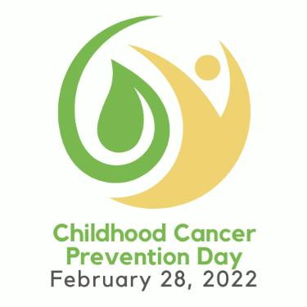
The images above can be used as a profile picture for any social media page.

FACEBOOK
The logo-only profile picture could be used with a self-created Facebook frame.
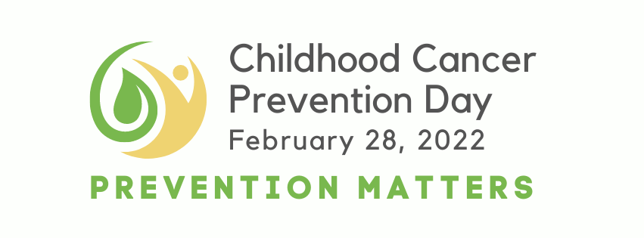
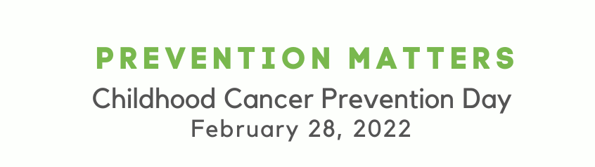
The second Facebook Cover Image can be used in combination with the logo as the profile picture.

PREP4Gold will be busy during the day on Facebook! Visit to share additional information on your page. We will highlight information, recent articles, and some ideas to share the importance of prevention in your community.

Consider utilizing Facebook LIVE to tell the community why Childhood Cancer Prevention Matters to YOU! To learn more about how to do it: https://www.facebook.com/help/iphone-app/1636872026560015/

TWITTER
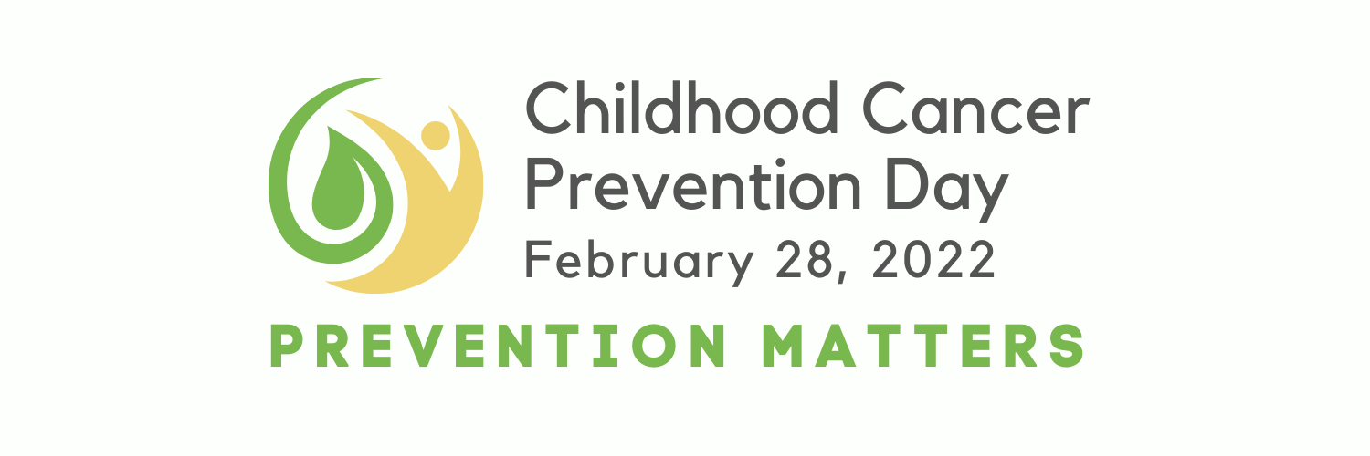

References to Childhood Cancer Prevention Day on Twitter can have a great impact on the community, especially since teens and young adults are more likely to use Twitter than Facebook.

Help spread the word about Childhood Cancer Prevention Day with the hashtags: #ChildhoodCancerPreventionDay #PreventionMatters
#PreventionIsPossible #PreventChildhoodCancer #ProtectKids
And follow us during the day @PREP4Gold.

LINKEDIN
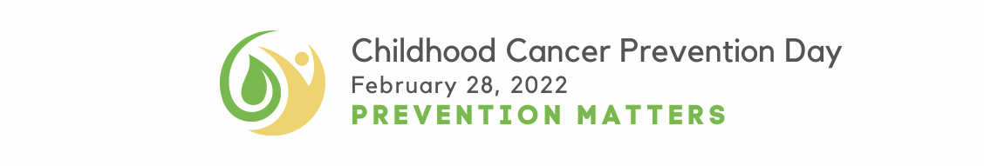

LinkedIn is the platform to better connect on social media with your colleagues, partners and fellow businesses in your community. An advocacy campaign like Childhood Cancer Prevention Day is a great way to increase your presence among businesses, funders, and nonprofit peers, and guide them to your website, blogs and upcoming news and events. Impress upon them the importance of prevention, and that it is possible to help protect our children.

INSTAGRAM

As the platform preferred by many teens and young adults, Instagram is a great way to reach out to today’s teens - our emerging advocates - to invite them to raise awareness among their peers for a healthier tomorrow!

SOCIAL MEDIA SAMPLE POSTS/TWEETS

With 46 kids diagnosed each day, #ChildhoodCancer is on the rise. Help us make a difference and protect our children. #PreventionMatters #ChildhoodCancerPreventionDay

Globally, we have experienced a 41% increase in #ChildhoodCancer diagnoses since 1975. We need to do more to protect our children. #PreventionMatters #ChildhoodCancerPreventionDay

We can prevent many children from developing #ChildhoodCancer. #PreventionIsPossible #ChildhoodCancerPreventionDay

#ChildhoodCancer is the #1 disease killer of our children. The time is NOW to protect our kids. #PreventionMatters #ChildhoodCancerPreventionDay

More than 95% of #childhood cancer #survivors will have a significant health related issue by the time they are 45 yrs old. Protect our children today, so they have a better tomorrow. #PreventionMatters #ChildhoodCancerPreventionDay

10% of #ChildhoodCancer #Survivors experience a second cancer diagnosis. We need gentler treatments today, to protect survivors against additional cancer tomorrow. #PreventionMatters #ChildhoodCancerPreventionDay

Female #ChildhoodCancer #Survivors are 6X more likely than the general population to be diagnosed with breast cancer later in life. #PreventionMatters #ChildhoodCancerPreventionDay

SOCIAL MEDIA SAMPLE IMAGES

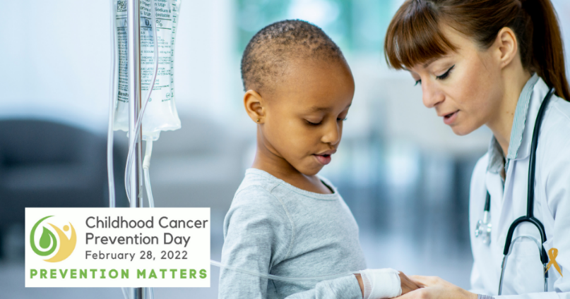

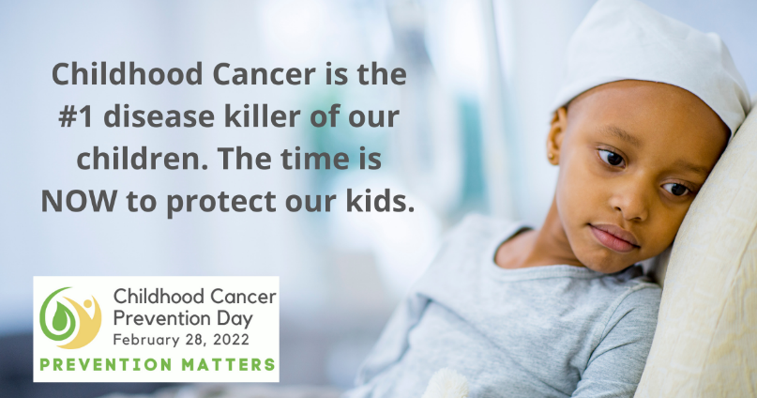

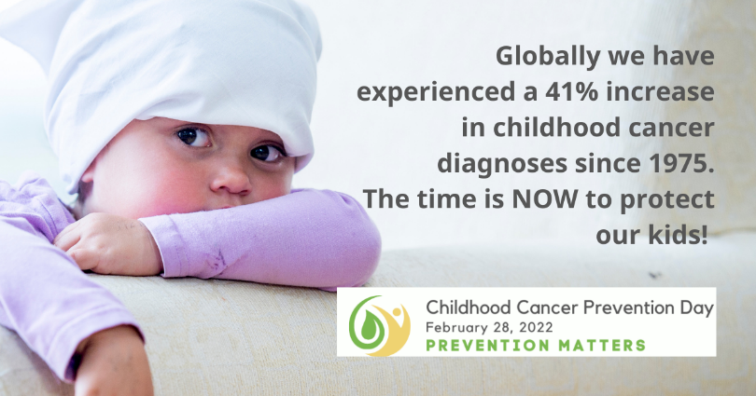

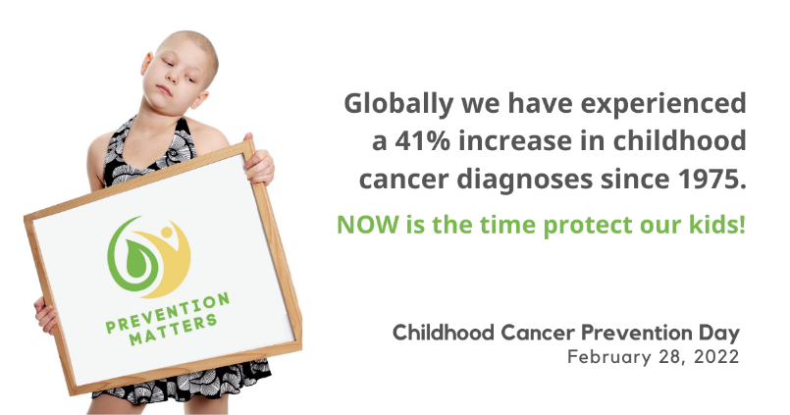

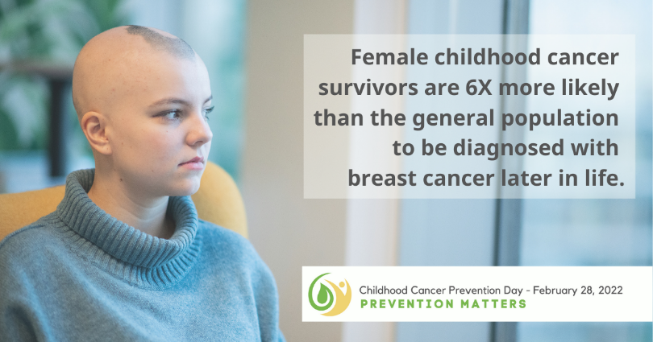

ADDITIONAL RESOURCES
Sharing additional resources on Childhood Cancer Prevention Day is a great way to help educate others about the possibility of prevention, and its importance. Find important resources to consider sharing here:

- Prep4gold.org/prevention
- Cancerfreeeconomy.org/childhood_cancer_prevention

Guidelines and Disclaimer
Childhood Cancer Prevention Week graphics may be used for educational and informational purposes in relation to the advocacy day, and information found on PREP4Gold.org. Use of Childhood Cancer Awareness Day images does not indicate any form of endorsement or approval from PREP4Gold.

